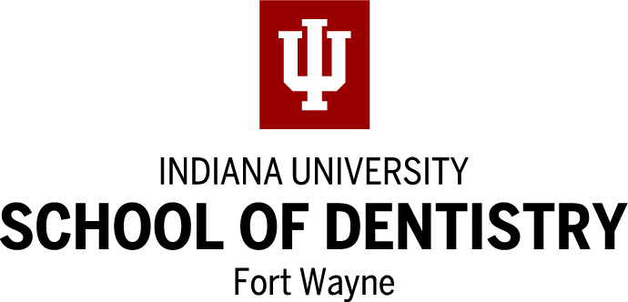
DENTAL HYGIENE PROGRAM
APPLICATION FOR ADMISSION
PLEASE NOTE:
THIS APPLICATION IS FOR THE IUFW DENTAL HYGIENE PROGRAM ONLY.
APPLICATIONS FROM OTHER PROGRAMS IN INDIANA WILL NOT BE ACCEPTED.
Personal Data
1. Name:
Last First Middle Initial Maiden Name

***Address:
Street Apartment #

City State Zip Code

Telephone ( ) E-mail ___________________________________________

*** This address is where ALL correspondence will be sent through July 1ST.
3. List high school attended & date of graduation:
4. Have you applied for admission to IUFW? Yes No
5. List all colleges and universities attended (including PFW):
Dates  Attended | Name of Institution | City & State | Full-time/  Part-time | Degree  Earned

6. List employment experiences:

Have you ever worked as a dental assistant or been employed in a dental office? Yes No
If yes, number of years: _____________________________________________

7. List skills you have that demonstrate good hand-eye coordination and/or good manual dexterity (i.e., typing, playing the piano, etc.):

8. Have you ever been on probation, suspended, dropped, or refused readmission at any college or university?
Yes No Uncertain (If the answer is Yes or Uncertain, please enclose written explanation.)

9. Have you previously applied to the IUFW Dental Hygiene Program?
Yes No If yes, in what year?

10. Indicate other dental hygiene programs to which you have submitted an application:
Indiana University School of Dentistry (Indianapolis)
Indiana University South Bend (South Bend)
Indiana University Northwest (Gary)
Ivy Tech Community College East Central (Anderson)
Ivy Tech Community College North Central (South Bend)
University of Southern Indiana (Evansville)
Other______________________________________
None

All application materials must be received by the Dental Hygiene Program office by February 1st. Please DO NOT send these materials to IUFW Admissions.

Your application will not be considered until the following materials are received:
1. Completed, signed IUFW Dental Hygiene Program Application.
Note: Applications from other programs will NOT be accepted.
2. IUFW Curriculum Information Form.
3. IUFW Dental Hygiene Observation Verification Form(s).
Applications will be accepted without observation forms for 2021 due to pandemic.
4. Official transcripts from ALL colleges and universities attended.
Note: IU, Purdue and IUFW students can submit unofficial transcripts.

FINAL ACTION WILL BE TAKEN FOLLOWING RECEIPT OF FINAL OFFICIAL SEMESTER TRANSCRIPTS.

Selection Process

- Applicants who meet all deadlines are ranked by their prerequisite GPAs on June 1.
- Applicants who rank among the top 24 students will be notified by email of their acceptance into the program on or before June 10.
- Applicants who rank 25 through 35 will be notified of their alternate acceptance status by June 10. They will receive full acceptance into the program if an opening occurs prior to the beginning of the fall semester.
- Applicants who are not accepted into the program will be notified by June 10 and are encouraged to repeat two prerequisite courses to raise their GPAs prior to reapplying to the program. Contact a dental hygiene advisor for information about the reapplication process.
- Your completed IUFW Dental Hygiene Program application satisfies application requirements for the IUFW Certified Dental Assisting Program. Indicate if you wish to have your application automatically submitted to the CDA program for consideration should you not be selected for the Dental Hygiene program. Please contact Program Director, Staci Schory for more information at srschory@iu.edu. ______ Yes ______ No

Please contact the IUFW Dental Hygiene Program office IMMEDIATELY at (260) 257-6819 if any of the information on this application changes in any way (i.e. address, phone number), or if you wish to withdraw your application.

I hereby give permission to the IUFW Dental Hygiene Program Admissions Committee to inspect my application and academic records.

Date: Signature:

DEPARTMENT USE ONLY: Date Application Received:

Updated December 2020

